**HALF ADDER USING ONLY NAND GATES**

**EXP NO.5:**

AIM: To show the working of half adder of NAND gates only using logisim.

Truth table:

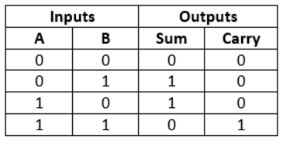

OUTPUT:

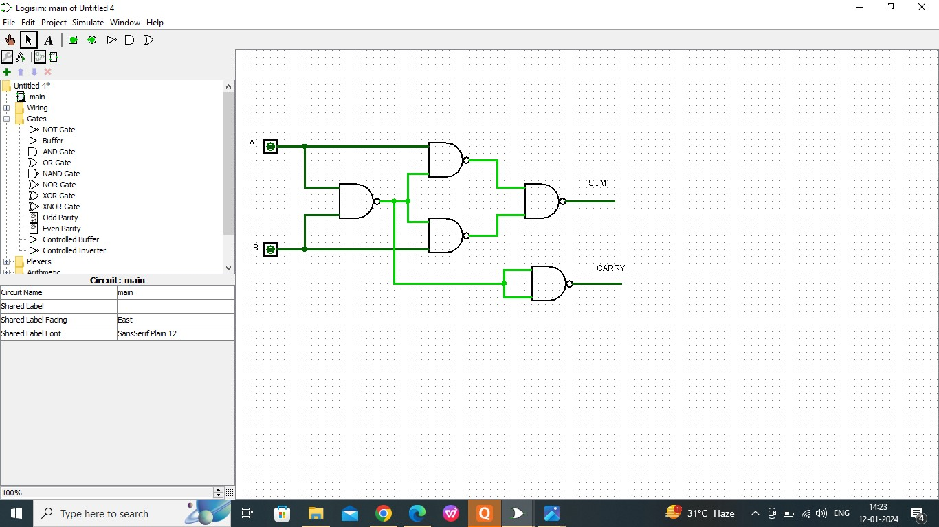

RESULT:

Thus the working of half adder has been observed successfully using logisim.